## 3Merchant

Demo date:   
Scoping start date: Nov 4, 2024

MSA Signature Date: Nov 6, 2024  
Onboarding Kick Off Date:

[If Exists] Opt Out Date:  
Go Live Date:

GTM POC: Daniel  
Implementation POC: Jeff

ERP: QBO

Tax Integration: No Tax - Manual for NY State (8.8%)

### 

### Key people at Merchant

### CEO: Ryan Janssen (ryan@zenlytic.com)

### Co-Founder: Paul Blankley (paul@zenlytic.com)

### Company summary

Zenlytic is the world’s first self-serve business intelligence (BI) platform, empowering users with re-imagined dashboards, self-serve exploration, and a generative AI data analyst to unlock actionable insights from their data effortlessly.

From retail and tech startups to manufacturing companies, Zenlytic delivers a full suite of business intelligence for all types of organizations.

Goals (North star)

What is the merchant's goal? What pain are we solving? Why are they buying Tabs?

* Move all billing and revenue workflows onto a single platform
* Transition credit card to ACH, particularly for larger clients to save on cost to collect
* Centralize and automate reporting (ASC 606, ARR, Cash Forecasting)
* Have a billing SOP that scales with their business

Is there an opt out clause? If so, what is the merchant looking for so that they don’t feel the need to exercise it?  
  
AE Notes

Any important relationship information  
  
1) What is Merchant Temperament?

*CEO is main POC. Very friendly and likes to joke a bit. Based in Miami but the company is HQ’d in Chelsea NYC.*

2) Is their key POC the buyer/decision maker?

*Yes - CEO is the main POC. May loop in the head of GTM as well.*

3) What are the Tabs features the key POC cares about?

*Revenue Reporting, ACH and Stripe integration (limitations to how their client can pay), Commercial Graph*

### Billing model

* Info on how merchant bills
  + *Pure SaaS billing ($10k to $200k depending on client)*
* How contract is broken up
  + *Annual upfront preferred, lots of monthly billing as well*
* One off things to know about merchant

### Billing model

* Are there unique things about the customer creation process for this merchant?
  + *They are currently using multiple systems which is not ideal. Their ideal flow is to have a contract created and sent through Docusign, pulled into Tabs, then pushed back to QBO. Billing is spread across HubSpot, Stripe, and QBO currently*

### Contract Processing Steps

1. Steps to process
   1. **Create customer**
      1. Customers are not coming from QB integration, need to use contract details to create in Tabs
      2. Customer name, address, email all found at top of contract

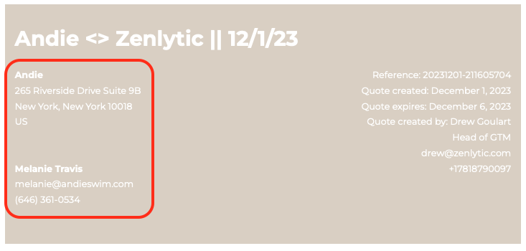

* 1. Billing terms all start under *Product and Services* section
  2. Use *Purchase Terms* section for payment cadence and billing start date
  3. Assume Net 30 terms unless stated otherwise

1. Anything to ignore in contracts?
2. Specifics processing things merchant has requested that may differ by contract (e.g. always back-date invoice date to final day of the month)
   1. **For NY State customers - manually add 8.8% Sales Tax (see** [**Andie**](https://garage.tabsplatform.com/prod/contracts/c5154dfc-240b-472b-9877-8a3f26fb71cc/terms/revenue)**)**
3. Default Service Term
   1. If None Listed, Ops Default is 1 Year
4. Default Net Payment Terms
   1. **30**
5. Default Billing Frequency
   1. Stated in *Purchase Terms*
6. How do we handle taxes as a line item?
   1. **Manually add 8.8% for NY state customers**
7. Implementation fee’s are ONE TIME only

### Events Processing (if necessary)

* Any important information on events billing

Integration Items Processing (if necessary)

[**Zenlytic | Integration Items**](https://docs.google.com/spreadsheets/d/1qolMlT1UhpIdgVxBGLFTQN1jsSRiUYAtErRlHunBSGA/edit?gid=0#gid=0)

* What are the instructions for assigning integration items?

**2 Software categories:**

* + **Zenlytic business intelligence license** 
    - **Default (platform cost, per seat - static doesn’t change much, etc)**
    - **DTaas - same business intelligence (rare, 2 customers, premium support)**
  + **Zenlytic embedded license** 
    - **Embedded license will always be called out in the contract**

Post Processing Communications (if necessary)

* Does Ops Team need to notify anyone on the team re: completion of processing batches in Implementation or Active phase?
* Who needs to be notified and when?
  + Let Azmat know in *#Zenlytic*

### Customer Information

* Any important information on specifics customers of this merchant
  + Special memo’s certain invoices require
    - *No*
  + Invoice changes due to merchant/customer relationship
    - *No*

### Feature Requests

* FR 1
  + What is it
  + Why it's important
  + Urgency

### Rewatch Calls

* [Tabs Intro Call](https://tabs.rewatch.com/video/gi6pps9ov5p0txnt-ryan-and-ali-november-4-2024) (11/4/24)